**Workflow of Juris Office Code Split Tool**

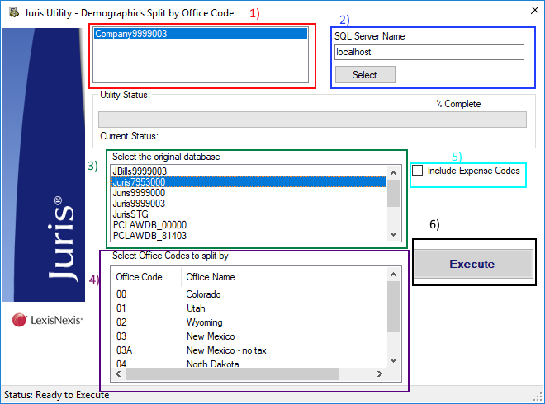

This application will copy data from the original client database to a Juris standard database (999900X) based on the selected Office Codes. It is broken down into 6 parts and are numbered in the order they should be performed in the diagram above.

1. Select the destination license. This must be an installed license on the machine Juris is installed on.
2. Type in the SQL Server name and instance (if required) where both databases reside. Both databases MUST reside on the same SQL Server. Click the “Select” button once you have entered the SQL Server name/instance. This will populate the original Database list (step 3)
3. Select the original database. This is the database the client gives you and has the data we need to split. This will auto-populate based on the SQL Server name.
4. Once the original database is selected, the Office Codes will populate area 4. Select one or many Offices Codes you wish to split the data by. Only the selected Office Codes and related data will be brought over.
5. Check this box if you want to bring over expense codes. This is optional.
6. Click “Execute” to begin splitting the data. The progress bar will tell you how the application is progressing. Once the progress bar is at 100%, the process is finished, and the application can be closed

Now, you must verify the data before packaging it to send to the client.